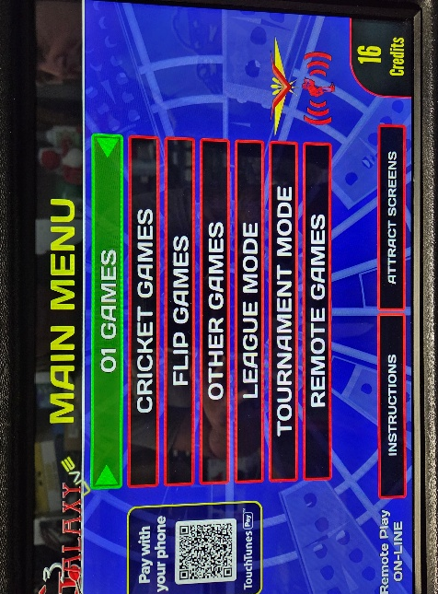

Choose “League Mode” On the dart board

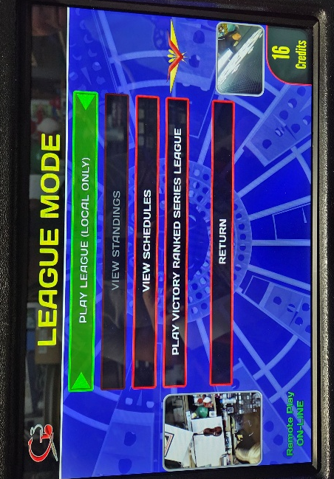

Then Select” Play League”

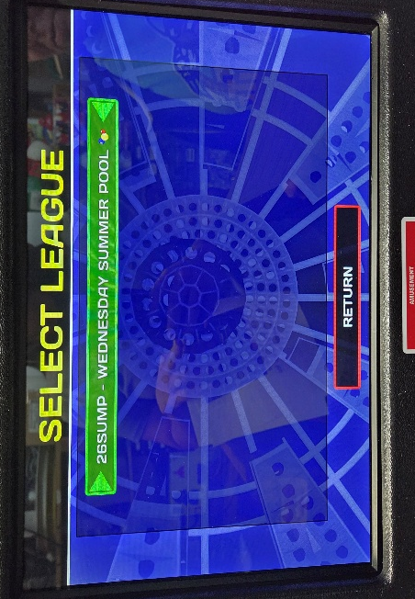

Now choose your specific league code
“26SUMP” Wednesday Summer Pool

Find your team and select it from the list
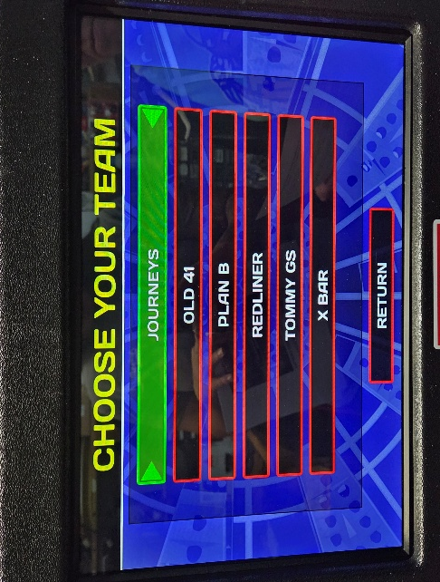

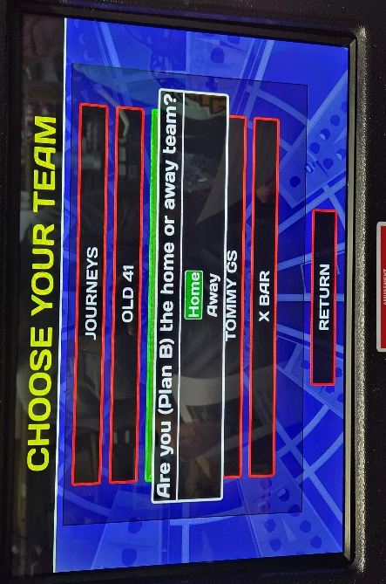

The board will ask if your team is home or away.
Choose the option according to the schedule.
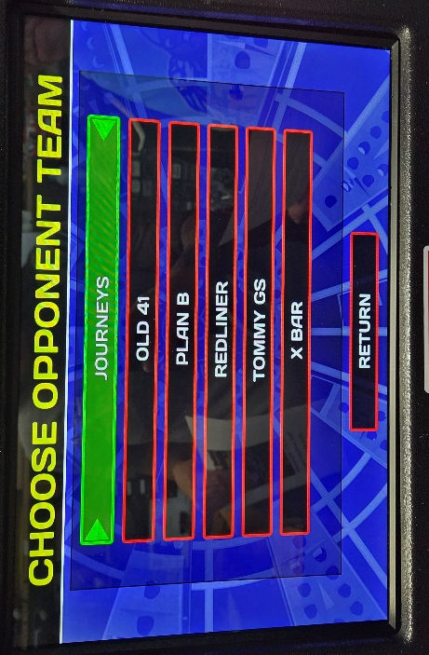

Then select your opponent.

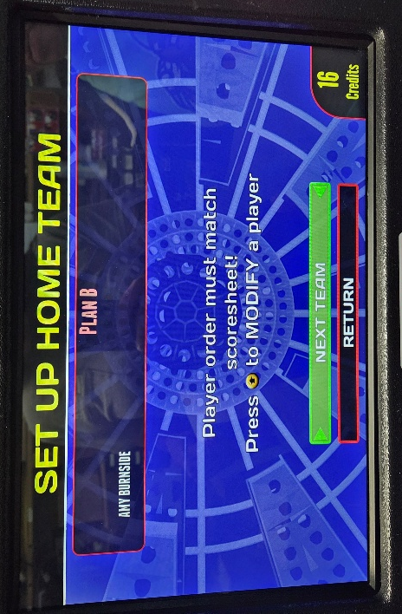

The board will then show one of your
team members (Captain). Please confirm you
selected the right team (No need to add subs here.
This is strictly for league fee purpose)

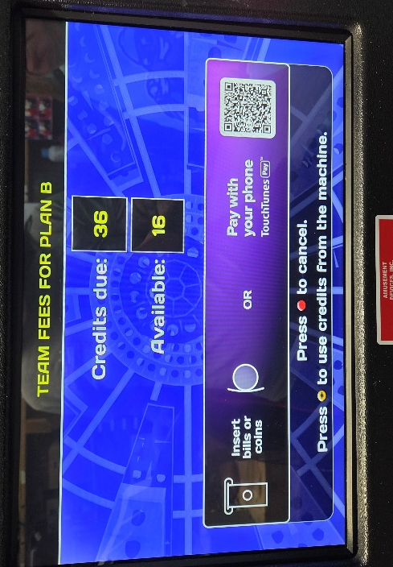

Please put team fees of ($9) per team.
The credits due will go down as it issues
credit for the money you put on the board
(Have correct bills as the board will not give change)

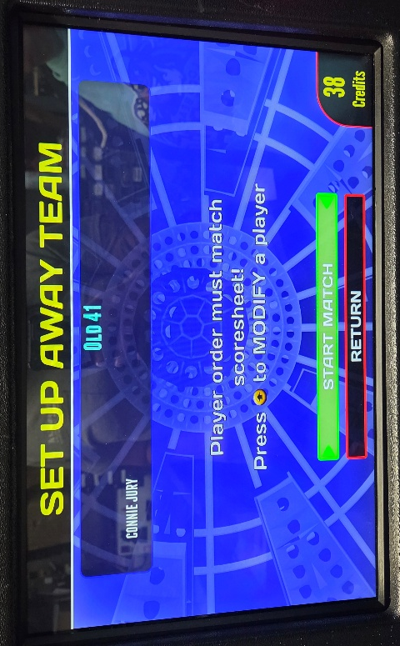

Now the AWAY team will confirm their team
and put team fees in the board.
Then choose “Start Match”

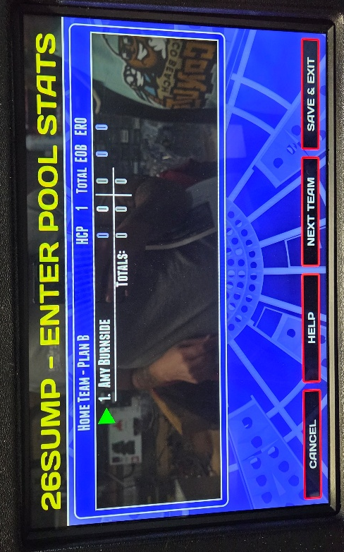

Only 1 player from each team will
be on the stats page. Arrow up or down to
put the green arrow next to the name.

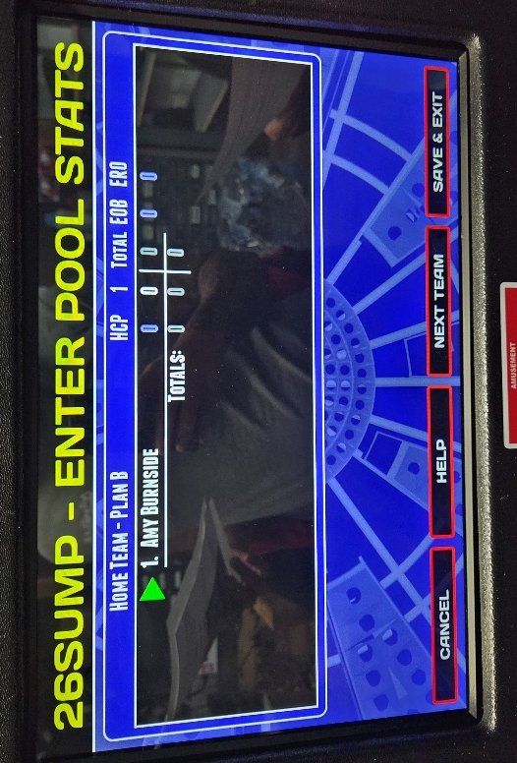

Once the green arrow is next to the player’s name…
Hit the red button to pull up the stats window.

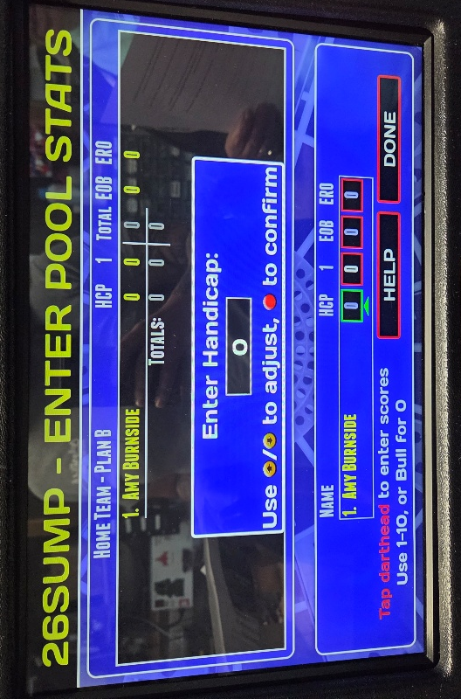

You don’t need to enter any values for the handicap.
Just confirm zero for this field.

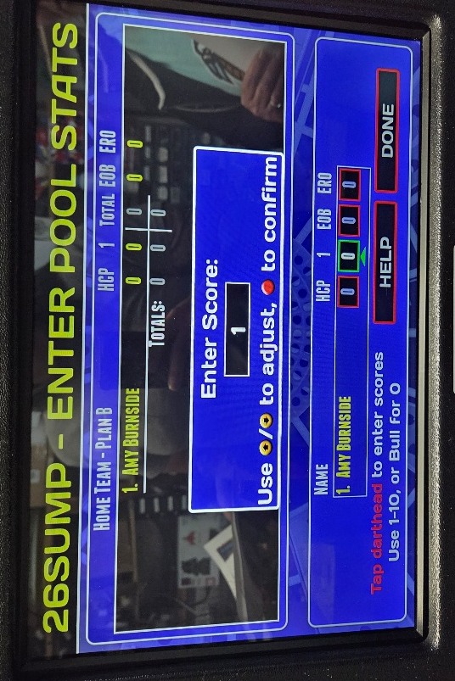
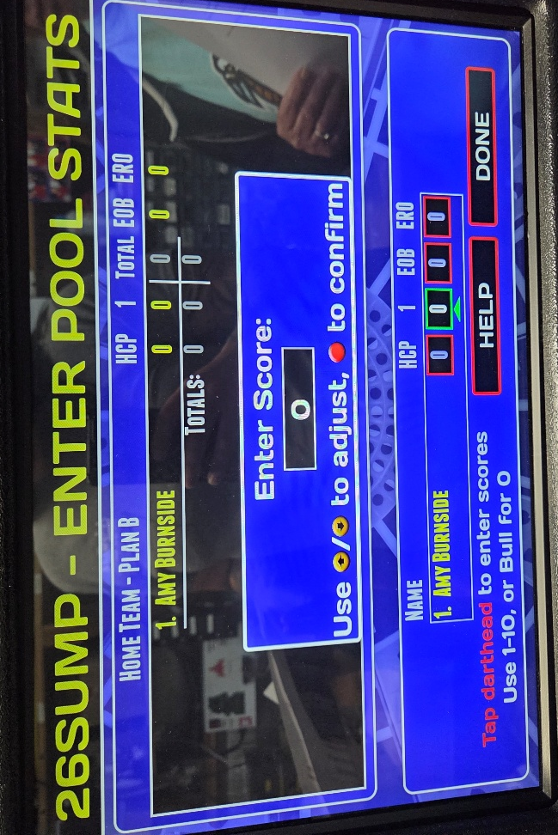
The next selection is the score.
YOU MUST ENTER A SCORE OF 1
FOR EITHER TEAM’S PLAYER.
If you don’t, then there will be no record
of the money put in the board.

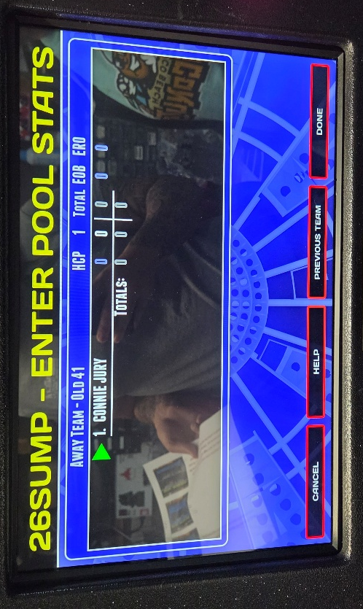

It doesn’t matter which player gets
the score but if you do it in the first team
then you can just hit done for the second player.

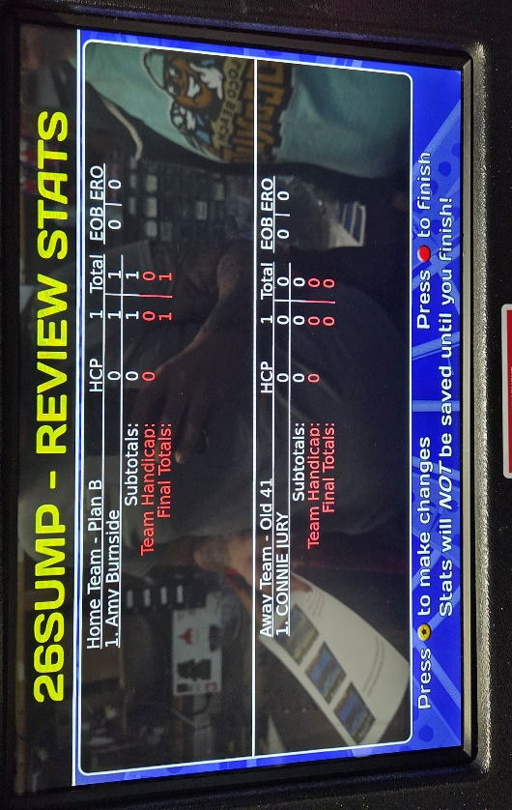
After you get through the score entry and
both players, you will see this screen.
Please confirm again that one player has a score of 1.
(If not, you will need to go back (up arrow)
to fix the score) If it is all correct then hit
the red button to finish.

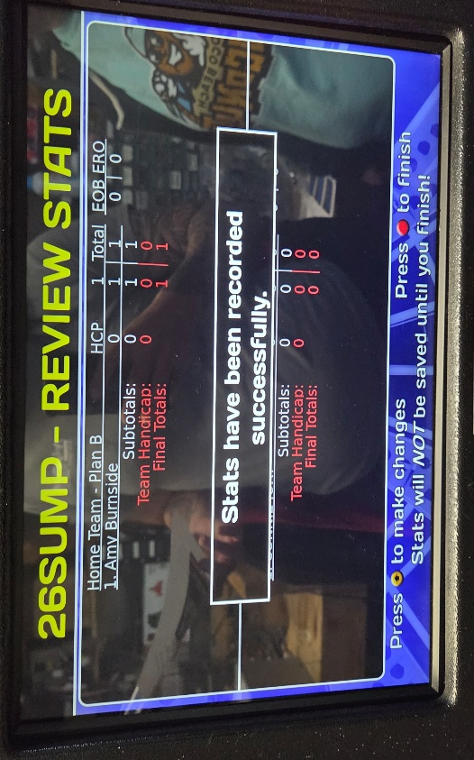

SUCCESS!!!! Once you have selected “Finish” …
you should see this message.
You are now ready to play your match!

